Федеральное государственное автономное образовательное учреждение высшего образования «Национальный исследовательский университет ИТМО»

Факультет программной инженерии и компьютерной техники

Основы дискретной математики

Курсовая работа. Часть №2

Синтез комбинационных схем

Вариант №98

Выполнил: студент группы P3108 Васильев Никита

Проверил: Поляков Владимир Иванович, доцент факультета ПИиКТ, кандидат технических наук

Санкт-Петербург 2024

|  |  |  |  |  |  |  |
| --- | --- | --- | --- | --- | --- | --- |
| **№** | **Выполняемые операции** | **Число переменных** | | **Разрядность операндов** | | **Фиксация переноса, заема, или переполнения** |
| **Входных** | **Выходных** | **A** | **B** |
| **98** | $$C={(A±1)}_{mod13}$$ | 5 | 5 | 4 | - | * |

# Таблица истинности

$$C={A±1}_{mod13}, y=\left\{\begin{aligned}0 для C=A+1 \\ 1 для C=A-1\end{aligned}\right.$$

|  |  |  |  |  |  |  |  |  |  |
| --- | --- | --- | --- | --- | --- | --- | --- | --- | --- |
| $$y$$ | $$a_{1}$$ | $$a_{2}$$ | $$a_{3}$$ | $$a_{4}$$ | $$C_{1}$$ | $$C_{2}$$ | $$C_{3}$$ | $$C_{4}$$ | $$V$$ |
| 0 | 0 | 0 | 0 | 0 | 0 | 0 | 0 | 1 | 0 |
| 0 | 0 | 0 | 0 | 1 | 0 | 0 | 1 | 0 | 0 |
| 0 | 0 | 0 | 1 | 0 | 0 | 0 | 1 | 1 | 0 |
| 0 | 0 | 0 | 1 | 1 | 0 | 1 | 0 | 0 | 0 |
| 0 | 0 | 1 | 0 | 0 | 0 | 1 | 0 | 1 | 0 |
| 0 | 0 | 1 | 0 | 1 | 0 | 1 | 1 | 0 | 0 |
| 0 | 0 | 1 | 1 | 0 | 0 | 1 | 1 | 1 | 0 |
| 0 | 0 | 1 | 1 | 1 | 1 | 0 | 0 | 0 | 0 |
| 0 | 1 | 0 | 0 | 0 | 1 | 0 | 0 | 1 | 0 |
| 0 | 1 | 0 | 0 | 1 | 1 | 0 | 1 | 0 | 0 |
| 0 | 1 | 0 | 1 | 0 | 1 | 0 | 1 | 1 | 0 |
| 0 | 1 | 0 | 1 | 1 | 1 | 1 | 0 | 0 | 0 |
| 0 | 1 | 1 | 0 | 0 | 0 | 0 | 0 | 0 | 1 |
| 0 | 1 | 1 | 0 | 1 | d | d | d | d | d |
| 0 | 1 | 1 | 1 | 0 | d | d | d | d | d |
| 0 | 1 | 1 | 1 | 1 | d | d | d | d | d |
| 1 | 0 | 0 | 0 | 0 | 1 | 1 | 0 | 0 | 1 |
| 1 | 0 | 0 | 0 | 1 | 0 | 0 | 0 | 0 | 0 |
| 1 | 0 | 0 | 1 | 0 | 0 | 0 | 0 | 1 | 0 |
| 1 | 0 | 0 | 1 | 1 | 0 | 0 | 1 | 0 | 0 |
| 1 | 0 | 1 | 0 | 0 | 0 | 0 | 1 | 1 | 0 |
| 1 | 0 | 1 | 0 | 1 | 0 | 1 | 0 | 0 | 0 |
| 1 | 0 | 1 | 1 | 0 | 0 | 1 | 0 | 1 | 0 |
| 1 | 0 | 1 | 1 | 1 | 0 | 1 | 1 | 0 | 0 |
| 1 | 1 | 0 | 0 | 0 | 0 | 1 | 1 | 1 | 0 |
| 1 | 1 | 0 | 0 | 1 | 1 | 0 | 0 | 0 | 0 |
| 1 | 1 | 0 | 1 | 0 | 1 | 0 | 0 | 1 | 0 |
| 1 | 1 | 0 | 1 | 1 | 1 | 0 | 1 | 0 | 0 |
| 1 | 1 | 1 | 0 | 0 | 1 | 0 | 1 | 1 | 0 |
| 1 | 1 | 1 | 0 | 1 | d | d | d | d | d |
| 1 | 1 | 1 | 1 | 0 | d | d | d | d | d |
| 1 | 1 | 1 | 1 | 1 | d | d | d | d | d |

# Минимизация на картах Карно

|  |  |  |  |  |  |  |
| --- | --- | --- | --- | --- | --- | --- |
|  | a3a4 | | | | | |
| a1a2 |  | | **00** | **01** | **11** | **10** |
| **00** | | 1 |  |  |  |
| **01** | |  |  |  |  |
| **11** | | 1 | d | d | d |
| **10** | |  | 1 | 1 | 1 |
|  | | y = 1 | | | | |

## Определение МДНФ

C1:

|  |  |  |  |  |  |  |
| --- | --- | --- | --- | --- | --- | --- |
|  | a3a4 | | | | | |
| a1a2 |  | | **00** | **01** | **11** | **10** |
| **00** | |  |  |  |  |
| **01** | |  |  | 1 |  |
| **11** | |  | d | d | d |
| **10** | | 1 | 1 | 1 | 1 |
|  | | y = 0 | | | | |

C2:

|  |  |  |  |  |  |  |
| --- | --- | --- | --- | --- | --- | --- |
|  | a3a4 | | | | | |
| a1a2 |  | | **00** | **01** | **11** | **10** |
| **00** | |  |  | 1 |  |
| **01** | | 1 | 1 |  | 1 |
| **11** | |  | d | d | d |
| **10** | |  |  | 1 |  |
|  | | y = 0 | | | | |

|  |  |  |  |  |  |  |
| --- | --- | --- | --- | --- | --- | --- |
|  | a3a4 | | | | | |
| a1a2 |  | | **00** | **01** | **11** | **10** |
| **00** | | 1 |  |  |  |
| **01** | |  | 1 | 1 | 1 |
| **11** | |  | d | d | d |
| **10** | | 1 |  |  |  |
|  | | y = 1 | | | | |

C3:

|  |  |  |  |  |  |  |
| --- | --- | --- | --- | --- | --- | --- |
|  | a3a4 | | | | | |
| a1a2 |  | | **00** | **01** | **11** | **10** |
| **00** | |  | 1 |  | 1 |
| **01** | |  | 1 |  | 1 |
| **11** | |  | d | d | d |
| **10** | |  | 1 |  | 1 |
|  | | y = 0 | | | | |

|  |  |  |  |  |  |  |
| --- | --- | --- | --- | --- | --- | --- |
|  | a3a4 | | | | | |
| a1a2 |  | | **00** | **01** | **11** | **10** |
| **00** | |  |  | 1 |  |
| **01** | | 1 |  | 1 |  |
| **11** | | 1 | d | d | d |
| **10** | | 1 |  | 1 |  |
|  | | y = 1 | | | | |

C4:

|  |  |  |  |  |  |  |
| --- | --- | --- | --- | --- | --- | --- |
|  | a3a4 | | | | | |
| a1a2 |  | | **00** | **01** | **11** | **10** |
| **00** | | 1 |  |  | 1 |
| **01** | | 1 |  |  | 1 |
| **11** | |  | d | d | d |
| **10** | | 1 |  |  | 1 |
|  | | y = 0 | | | | |

|  |  |  |  |  |  |  |
| --- | --- | --- | --- | --- | --- | --- |
|  | a3a4 | | | | | |
| a1a2 |  | | **00** | **01** | **11** | **10** |
| **00** | |  |  |  | 1 |
| **01** | | 1 |  |  | 1 |
| **11** | | 1 | d | d | d |
| **10** | | 1 |  |  | 1 |
|  | | y = 1 | | | | |

V:

|  |  |  |  |  |  |  |
| --- | --- | --- | --- | --- | --- | --- |
|  | a3a4 | | | | | |
| a1a2 |  | | **00** | **01** | **11** | **10** |
| **00** | |  |  |  |  |
| **01** | |  |  |  |  |
| **11** | | 1 | d | d | d |
| **10** | |  |  |  |  |
|  | | y = 0 | | | | |

|  |  |  |  |  |  |  |
| --- | --- | --- | --- | --- | --- | --- |
|  | a3a4 | | | | | |
| a1a2 |  | | **00** | **01** | **11** | **10** |
| **00** | | 1 |  |  |  |
| **01** | |  |  |  |  |
| **11** | |  | d | d | d |
| **10** | |  |  |  |  |
|  | | y = 1 | | | | |

|  |  |
| --- | --- |
|  |  |
|  |  |
|  |  |
|  |  |
|  |  |

# Преобразование минимальных форм булевой функции

Введем вспомогательную переменную $Z=y\overline{a_{1}}\overline{a_{2}}\overline{a_{3}}\overline{a_{4}}$ и приведем функции к скобочной форме.

|  |  |
| --- | --- |
| $Z=y\overline{a_{1}}\overline{a_{2}}\overline{a_{3}}\overline{a_{4}}$ | $$S_{q}^{Z}=5$$ |
| $$C_{1}=Z∨a_{1}(\overline{y}\overline{a_{2}}∨ya_{2}∨a_{3}∨a_{4})∨\overline{y}a_{2}a_{3}a_{4}$$ | $$S_{q}^{C_{1}}=17$$ |
| $$C_{2}=y\overline{a_{2}}\overline{a_{3}}\overline{a_{4}}∨\overline{y}\overline{a_{2}}a_{3}a_{4}∨ya_{2}a_{3}∨a_{2}\overline{a_{3}}a_{4}∨\overline{y}\overline{a_{1}}a_{2}\overline{a_{4}}$$ | $$S_{q}^{C_{2}}=23$$ |
| $$C_{3}=y\overline{a_{3}}\overline{a_{4}}(a_{1}∨a_{2})∨\overline{y}a_{3}\overline{a_{4}}∨\overline{y}\overline{a_{3}}a_{4}∨ya_{3}a_{4}$$ | $$S_{q}^{C_{3}}=19$$ |
| $$C_{4}=\overline{a_{4}}(a_{3}∨\overline{y}\overline{a_{2}}∨ya_{1}∨\overline{a_{1}}a_{2})$$ | $$S_{q}^{C_{4}}=12$$ |
| $$V=Z∨\overline{y}a_{1}a_{2}$$ | $$S_{q}^{V}=5$$ |

$$S_{q}^{Σ}=81$$

Введем новые вспомогательные переменные $Z_{1}$– $Z_{6}$ и преобразуем функции системы.

|  |  |
| --- | --- |
| $Z_{1}=\overline{a_{3}}\overline{a_{4}}$ | $$S_{q}^{Z_{1}}=2$$ |
| $Z_{2}=a_{3}a_{4}$ | $$S_{q}^{Z_{2}}=2$$ |
| $$Z_{3}=ya_{2}$$ | $$S_{q}^{Z_{3}}=2$$ |
| $$Z_{4}=\overline{y}a_{2}$$ | $$S_{q}^{Z_{4}}=2$$ |
| $$Z_{5}=\overline{y}\overline{a_{2}}$$ | $$S_{q}^{Z_{5}}=2$$ |
| $$Z_{6}=y\overline{a_{1}}\overline{a_{2}}Z_{1}$$ | $$S_{q}^{Z_{6}}=4$$ |
| $$C_{1}=Z_{6}∨a_{1}(Z_{5}∨Z_{3}∨\overline{Z_{1}})∨Z_{2}Z_{4}$$ | $$S_{q}^{C_{1}}=11$$ |
| $$C_{2}=y\overline{a_{2}}Z_{1}∨Z_{2}Z_{5}∨a_{3}Z_{3}∨a_{2}\overline{a_{3}}a_{4}∨\overline{a_{1}}\overline{a_{4}}Z_{4}$$ | $$S_{q}^{C_{2}}=18$$ |
| $$C_{3}=yZ_{1}(a_{1}∨a_{2})∨\overline{y}(\overline{Z_{1}∨Z_{2}})∨yZ_{2}$$ | $$S_{q}^{C_{3}}=15$$ |
| $$C_{4}=\overline{a_{4}}(a_{3}∨Z_{5}∨ya_{1}∨\overline{a_{1}}a_{2})$$ | $$S_{q}^{C_{4}}=10$$ |
| $$V=Z_{6}∨a_{1}Z_{4}$$ | $$S_{q}^{V}=4$$ |

$$S_{q}^{Σ}=72$$

# Синтез многовыходной комбинационной схемы в булевом базисе

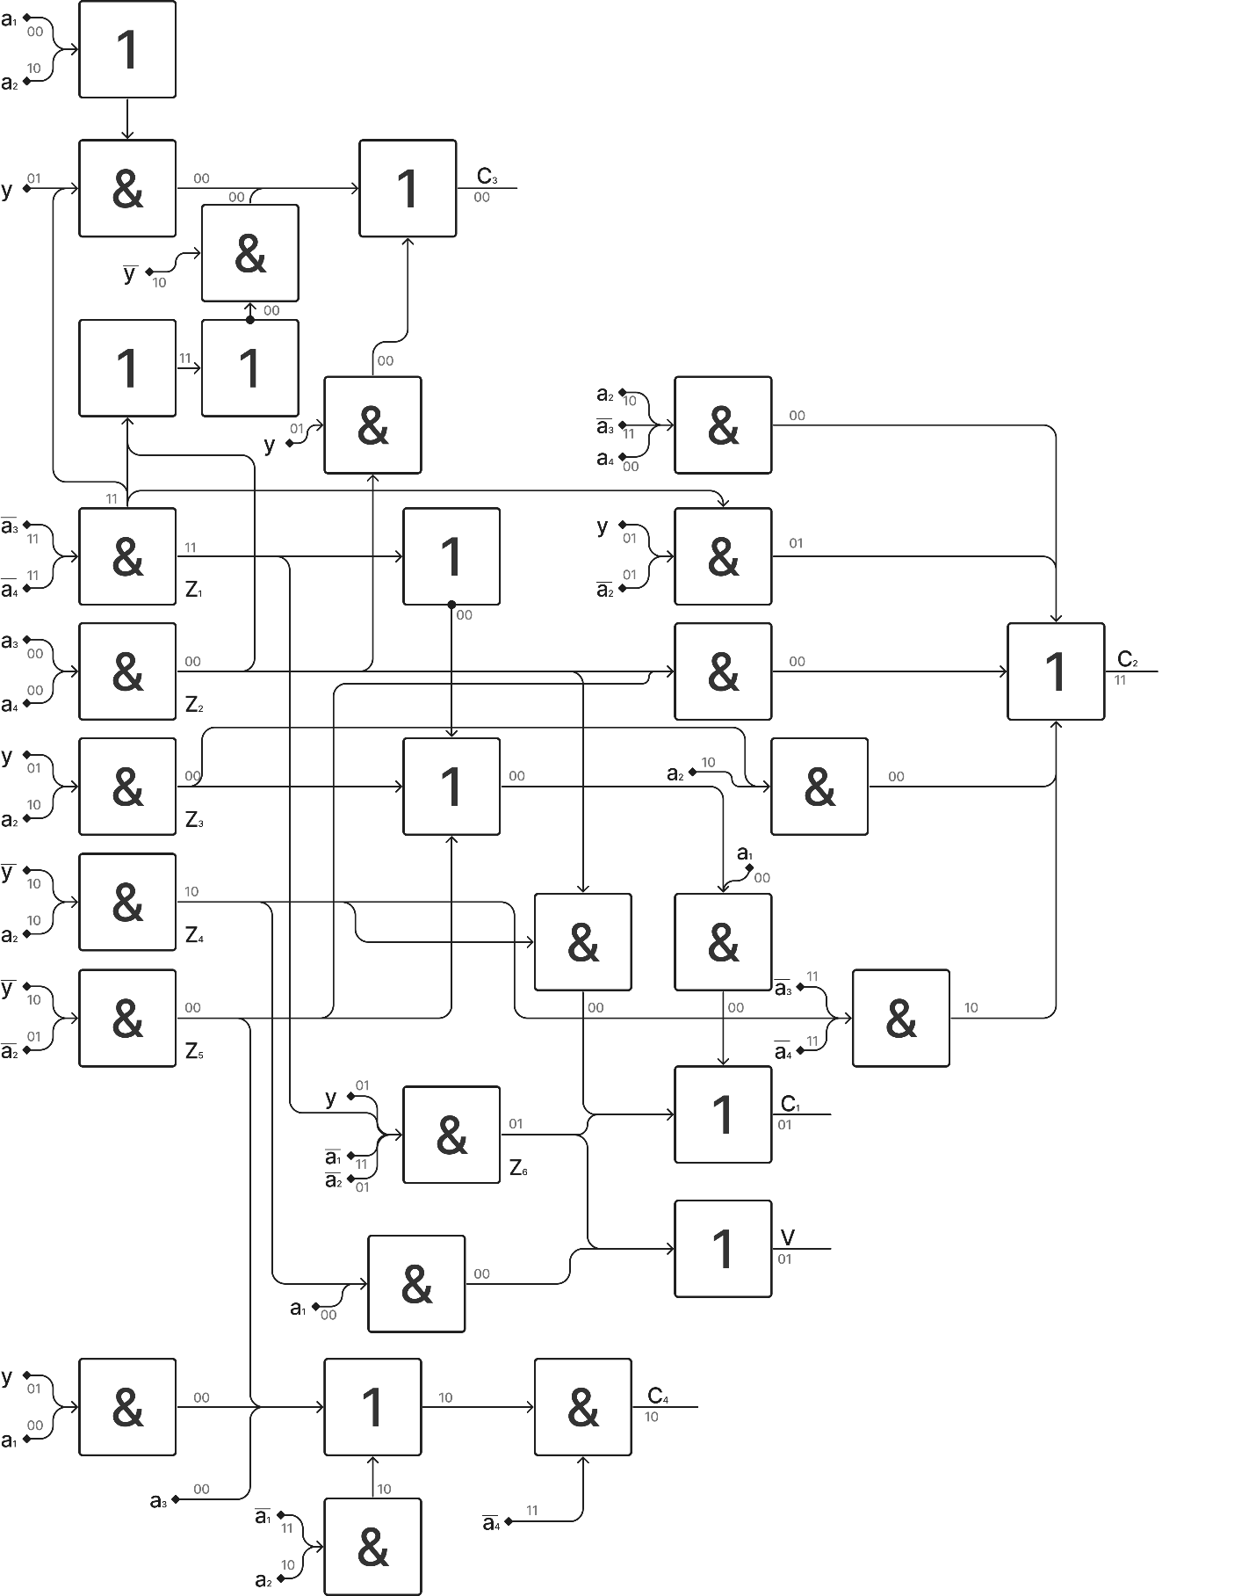

$$S_{q}^{Σ}=72$$

$$T=5τ$$

# Анализ схем

Анализ произведен на наборах:

$$f\left(\left[y=0,a_{1}=0,a_{2}=1,a_{3}=0,a_{4}=0\right]\right)=\left[C_{1}=0,C_{2}=1,C_{3}=0,C_{4}=1, V=0\right]$$

$$f\left(\left[y=1,a_{1}=0,a_{2}=0,a_{3}=0,a_{4}=0\right]\right)=\left[C_{1}=1,C_{2}=1,C_{3}=0,C_{4}=0, V=1\right]$$